1. What are system calls? List the types of system calls (6 types)

* A system call is a mechanism that provides the interface between a process and the operating system. It is a programmatic method in which a computer program requests a service from the kernel of the OS.
* System call offers the services of the operating system to the program via API (Application programming interface). System calls are the only entry points for the kernel system.
* TYPES OF SYSTEM CALLS :-
* Process Control
* File Management
* Device Management
* Information Maintenance
* Communication
* Protection
* Explanation of system calls:

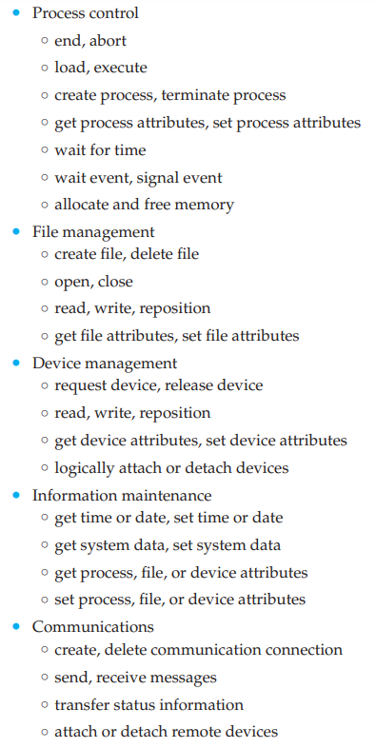

1. What are operating system services?

An operating system provides an environment for the execution of programs and it also provides certain services to program and to the users of that/those programs

There are 9 operating system services

1. User Interface :-

It is one of the most important services provided by the operating systems

It allows the user to interact with the operating system or to interact with the computer itself almost all operating systems have a user interface

1. Program Execution :-

The OS loads a program into memory and then executes that program

It also makes sure that once started that program can end its execution, either normally or forcefully.

1. File system manipulation :-

A program is read and then written in the form of directories and files. These files can be stored on the storage disk for the long term.

The OS allows the user to create and delete files, duplicate these files and search files and their information or properties

1. Input Output Operator :-

These operating are required during the execution of a program

To maintain efficiency and protection of the program, users directly govern the input output devices instead. The OS allows to read or write operations with any fiile using the input output devices and also allows access to any required input output device when required.

1. Communication Systems :-

These operations helps in the sharing of information which can be from the same or different system as long as they are connected through communication lines in a network.

The OS also manages routing, connection strategies ad the problem of contention and security.

1. Resource allocation :-

When multiple users or multiple jobs run on a system concurrently, the resource need to be allocated equally to all of them.

CPU scheduling is used to allocate resources fairly and for the better utilisation of the CPU

1. Error detection
2. Accounting
3. Protection and security
4. Command interpretation
5. What is operating system?

An operating system is a software that acts as an interface between computer hardware components and the user. Every computer system must have at least one operating system to run other programs. Applications like browsers, MS Office, notepad games, etc. need some environment to run and perform its tasks. The OS helps you to run and perform its tasks. The OS helps you to communicate with the computer without knowing how to speak the computers language. It is not possible for the user to use any computer or device without having an operating system.

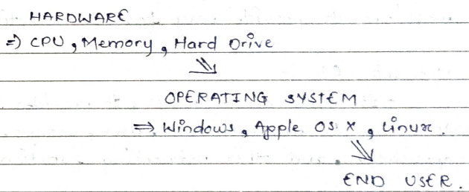

* Types of Operating system :-
* Batch Operating System :-

Some computer processes are very lengthy and consuming. To speed the same process, a job with a similar type of needs are batched together and run a group.

* Multi-tasking / Time sharing operating systems :-  
  Time sharing operating systems enables people locates at a different terminal to use a single computer system at the same time. The processor time (CPU) which is shared among multiple users is termed as time-sharing.
* Real time OS :-  
  A real time OS time interval to process and respond to inputs is very small.
* Distributed OS :-  
  it uses many processors located in different machines very fast computation to its users.
* Network OS :-  
  it runs on a server. It provides the capability to serve to manage data, user, groups, security, application and other networking functions.
* Mobile OS :-  
  Mobile OS are those OS which are especially designed to power smartphones, tablets and wearable devices.

1. What are computer system organisation?

The computer system is a combination of many parts such as peripheral devices, secondary memory, CPU, etc. This can be explained more clearly using the following diagram:

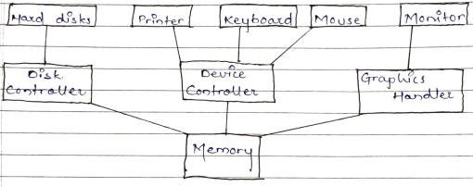

The salient points about the above figure displaying computer system organisation is –

* + The I/O devices and the CPU both execute concurrently. Some of the processes are schedules for the PCU and at the same time, some are undergoing I/O operations.
  + These are multiples devices controllers, each in charge of a particular device such as keyboard, mouse, pointer, etc
  + There is buffer available for each of the devices. The input and output data can be stored in those buffers.
  + The data is moved from memory to the respective device buffers by the CPU for the I/O operations and this data is moved back from the buffers to memory.
  + The device controllers used an interrupt to inform the CPU that I/O operation is completed.

1. What is DMA controller?

DMA controller definition is, an external device that is used to control the data transfer between memory and I/O device without the processor involvement is known DMA controller. This controller has the capacity to access the memory directly to read or write operations. DMA controller was implemented by Intel for having very fast data transfer with less utilisation of the processor.

The direct memory access controller produces memory address and it covers numerous hardware registers that can be read and written through the CPU. These registers mainly include a byte count, memory address an minimum of one or above control registers. So based on the DMA controller features, these registers can select some combination of source, destination, transfer direction, the transfer unit size and the number of bytes to move within the single burst.

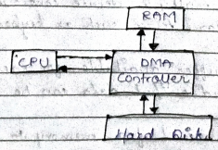

To execute different operations like input and output otherwise memory to memory. The host processor initialises the controller by the number of words to transmit and the memory address to utilize, then the CPU orders the peripheral device to start data transfer.

The DMU controller provides address and reads or writes control lines toward the system memory. Every time, a data byte is arranged to be transmitted in between the memory and peripheral device, the controller increases its inside address register until a whole data block is transmitted.

1. What is multi-processor system?

A multiprocessor system is defined as “a system with more than one processor”. And more precisely, “a number of central processing units linked together to enable parallel processing to take place”.

The key parallel objective of a multiprocessor is to boost a system’s execution speed. The other objective are fault tolerance and application matching.

The term “multiprocessor” can be confused with the term “multiprocessing” while multiprocessing is a type of processing in which two or more processors work together to execute multiple programs simultaneously, multiprocessor refers to a hardware architecture that allows multiprocessing.

* Types of multiprocessor systems are:-
* Symmetric multiprocessor : In these type of systems, each processor contains similar copy of the operating system and they all communicate with each other, all the processor are a peer to peer relations i.e. no master-slave relationship exists between them.
* Asymmetric multiprocessor : In symmetric multiprocessor system, each program is given a predefined task. These is a master program that gives instruction to all the other processors, they contain a master slave relationship

1. What is operating system structure?

An operating system is a structured/construct that a user application program interact with the system hardware since the operating system is such a complex structure, it should be created with utmost care and can be used and modified easily. An easy way to do this is to create the OS in parts. Each of these should be well defined with clear input and output functions.

1. Simple structure:

There are many operating systems that have a rather simple structure. These started as small systems and expanded much further than their scope. A common example is MS-DOS.

Application Program

System Program

MS-DOS: Device Drivers

ROM BIOs: Device Drivers

It is better that operating system have a modular structure, unlike MS-DOS. That would lead to greater control over the computer system and its various applications. The modular structure would also allow the programmers to hide information as required and implement internal routines as they see fit without changing the outer specification.

1. Layered Structure:

One way to achieve modularity in the OS is the layered approach. In this, the bottom layer is hardware and the topmost layer is the user interface.

As seen from the above figure, each upper layer is built on the bottom layer. All the layers hide some structures, operations etc from their upper layers.

One problem with the layered structure is that each later need to be carefully defined, this is necessary because the upper layers can only use the functionalities of the layer below them.

1. What are operating system operations?

An operating system is a construct that allows the user application programs to interact with the system hardware. Operating system by itself does not provide any function but it provides an atmosphere in which different applications and programs can do useful work. The major operations of the operating system are process management, memory management, file management and device management.

1. Process management:  
   The OS is responsible for managing the process i.e. assigning the processor to a process at a time. This is known an process scheduling. The different algorithms used for process scheduling are (FCFS) First Come First Serve, (SJF) Shortest Job First, Priority Scheduling, round robin scheduling etc.  
   There are many different scheduling queues that are used to handle process in process management. When the processes enter the system, they are put into the job queue. The processes that are ready to execute in the main memory are kept in the ready queue.  
   The processes that are waiting for the I/O devices are kept in the device queue.
2. Memory Management:  
   Memory management plays an important part is ON. It deals with memory and the moving of processes from disk to primary memory for execution and back again. The activities performed by the operating system for memory management are:
   * The Operating system assigns memory to the processes are required. This can be done using the best fit, first fir and worst fit algorithms.
   * All the memory is tracked by the operating system i.e. it notes what memory parts are in use by the process and which are empty.
   * The operating system deallocated memory from processes are required. This may happen when a process has been terminated or if no longer needs the memory.
3. Device Management:  
   There are many I/O devices handled by the OS such as mouse, keyboard, disk drive etc. There are different device drivers that can be connected to the OS to handle a specific device. The device controller is a specific device. The device controller is an interface between the device and the device driver. The user applications can access all the I/O devices using the device drivers, which are device specific codes.
4. File Management:  
   Files are used to provide a uniform view of data storage by the operating system. All the files are mapped onto physical devices that are usually non volatile so data is safe in the case of the system failure.  
   The files can be accessed by the system in two ways:
   1. Sequential access:  
      The information in a file is processed in order using sequential access. The files records are accessed one after another. Most of the file system such as editors, compilers etc. are sequential access.
   2. Direct access:  
      In direct access or relative access, the files can be accessed in random for read and write operations. The direct access model is based on the disk model of a file. Since it allows random accesses.
5. What are system